SCRIPS
Click to close
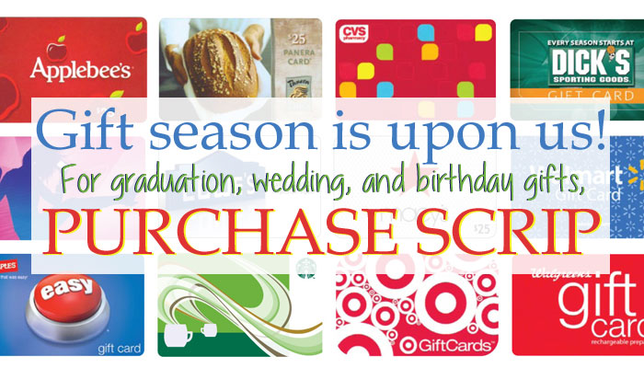It’s that time again! Everyone is starting to gear up for the holiday season! Here at KCS we have a wonderful program that we can utilize and we like to offer our families the convenience of SCRIP. SCRIP is a gift card company that pays us! It’s really an amazing thing…it doesn’t cost you anything and the convenience is worth a million dollars!
This is how it works:
1. Look at your gift list and weekly family spending habits​…remember birthdays, holidays, special occasions, college students (love a gift card for coffee shops, food and gas!), high school students on the go (food, entertainment, clothing, etc), weekly spending for your family (groceries, gas, dining out, entertainment, home repairs, etc), and HOLIDAY SHOPPING SPOTS (including lunch while you shop)…you get the idea!
2. Download this form, find your needs on the list and fill in how many you want of each card. Total at the bottom of each sheet.
3. Add the totals up and write a check to KCS in the amount of the purchase. Example: If you purchase a $25 gift card from O’Charley’s, you will receive a $25 gift card. The SCRIP company gives us 13% ($3.25) just because you ordered a card! It’s really very simple! The percentage that the school receives is clearly stated on the order form.
4. Orders with payment must be turned in by 11am on Monday or you can email the order to rbrandenburg@kcsknights.org and pay for your SCRIP order online if you add a 3% convenience fee to your total order. The cards will be ready to pick up or be sent home with your child on Wednesday. It’s not only convenient, it’s quick too!
5. We would like to make this a year round program! We will begin the program on Monday November 28th. There will not be any SCRIP orders during the Christmas break. The last order before the break will be Monday December 12th and we will resume on Monday January 9th.
6. Call Rikki Brandenburg at 865-966-7060 Monday-Thursday 7:00 am-2:30 pm if you have any questions.

Download
SCRIP Form

What is SCRIP
When you hear the word “fundraising,” you probably associate it with pestering friends and family to buy from your abundant supply of wrapping paper, tubs of cookie dough, and trinkets galore. The truth is, the majority of fundraisers out there revolve around selling overpriced products that most people could live without. Sure, they bring in money if people are buying from you, but they’re never guaranteed to succeed. Scrip, on the other hand, offers big earnings with no selling— it’s fundraising while you shop®!
Instead of relying on families to become salespeople like other fundraising ideas do, families fundraising with scrip are raising money simply by changing their method of payment. They won’t be spending extra time, energy, or money on your fundraiser. In fact, once it’s up and running, scrip fundraising is simply integrated into your everyday life.
The only planning ahead you have to do is deciding what SCRIP you need to purchase, and even this revolves around your schedule. From taking on a home improvement project to planning a date night out to even just buying gas and groceries, you can order scrip beforehand and earn rebates every day!
Scrip is a lifestyle fundraiser. Families see how easy it is to earn just by purchasing a gift card, so after placing their first few orders, shopping with scrip becomes a habit. They’re continually motivated to shop with scrip because they can immediately see how much money they’re raising.
If you need a little more convincing, we came up with the top 4 reasons why scrip is the better fundraising solution for both your organization and your families.

Why Scrip is Better for Organizations?
1. You’re not spending time and energy trying to organize a fundraiser and sell overpriced products.
2. Scrip isn’t burdensome. You aren’t asking families to go out of their way to raise money. Instead, their everyday family purchases become immediate earnings for your organization.
3. The earnings add up fast! One family can generate $600 to $1000 or more per year just by paying with scrip.
4. There are no upfront costs and there’s no middleman taking a cut. Your organization receives every penny you earn.

Why Scrip is Better for Families
1. There are over 700 brands to choose from, so they can use scrip on practically every purchase.
2. Scrip is a great budgeting tool since families can use scrip for gas, groceries, and other household expenses.
3. Families can shop in-store or online at participating retailers.
4. Paying with gift cards keeps families safe from credit card fraud.
And the biggest benefit of all: everyone can participate in a scrip fundraiser because everyone makes monthly purchases.

